Short technical documentation of the algorithms applied for advisory self-classifications
The short document gives a description of how the advisory classifications were assigned to the chemical substances in the advisory self-classification list. This includes brief descriptions of the classification rules, the (Q)SARs used for predicting the dangerous properties of the substances and the algorithms by which the predictions from the (Q)SAR models were combined.

The selected dangerous properties
The following endpoints were addressed using (Q)SARs:

• Mutagenicity
• Carcinogenicity
• Reproductive toxicity (possible harm to the unborn child)
• Acute oral toxicity
• Sensitisation by skin contact
• Skin irritation
• Danger to the aquatic environment

(Q)SAR-predictions for these endpoints were used to assign the classifications listed in Table 1.

Dangerous property | Classification | Wording of CLP classification
Mutagenicity | Muta. 2 | Suspected of causing genetic defects
Carcinogenicity | Carc. 2 | Suspected of causing cancer
Reproductive toxicity | Repr. 2 | Suspected of damaging fertility or the unborn child
Acute oral toxicity | Acute Tox. 1 | Fatal if swallowed
Acute oral toxicity | Acute Tox. 2 | Fatal if swallowed
Acute oral toxicity | Acute Tox. 3 | Toxic if swallowed
Acute oral toxicity | Acute Tox. 4 | Harmful if swallowed
Sensitisation by skin contact | Skin Sens. 1 | May cause an allergic skin  reaction
Skin irritation | Skin Irrit. 2 | Causes skin irritation
Danger to the aquatic environment | Aquatic Acute 1 | Very toxic to aquatic life
Danger to the aquatic environment | Aquatic Chronic 1 | Very toxic to aquatic life with long lasting effects
Danger to the aquatic environment | Aquatic Chronic 2 | Toxic to aquatic life with long lasting effects
Danger to the aquatic environment | Aquatic Chronic 3 | Harmful to aquatic life with long lasting effects
Table 1: Advisory classifications in the CLP version of the advisory list

Mutagenicity
The criteria for classification for mutagenicity are divided into 3 different categories:

Classification as mutagenic, category 1A (Muta1A; H340: May cause genetic defects) is based on evidence of a causal association between human exposure to the substance and heritable genetic damage.

Classification as mutagenic, category 1B (Muta1B; H340: May cause genetic defects) is based on animal studies showing mutagenicity to germ cells either in assays on germ cells or by demonstrating mutagenic effects in somatic cells in vivo or in vitro as well as metabolic proof that the substances reaches the germ cells.

Classification as mutagenic, category 2 (Muta2; H341: Suspected of causing genetic defects) is based on animal studies showing mutagenity to germ cells either in assays on germ cells or by demonstrating mutagenic effects in somatic cells in vivo or in vitro as well as metabolic proof that the substances reaches the germ cells.

(Q)SAR based evaluation
Models predicting three genotoxicity in vivo endpoints and models predicting four genotoxicity in vitro endpoints were applied in the screening.

The models applied are all so-called battery models which integrate predictions from three individual models for the same endpoint and based on the same training set. To achieve a positive battery-prediction in domain, at least two of the three underlying models should be positive in domain. All the models are documented in the QSAR Model Reporting Format available at the Danish (Q)SAR database /1,2,3/. Brief results from 5 times two-fold cross-validations of the models are given in .

Endpoint | N (training set) | Software | Cross validation result (%)ª
Bacterial reverse mutation test (Ames test in S. typhimurium in vitro) | 4,102 | CASE Ultra | Sens=83.9, Spec=89.1, Conc=86.4,
 | 4,102 | Leadscope | Sens=84.3, Spec=85.7, Conc=84.9
 | 4,102 | SciQSAR | Sens=79.3, Spec=79.1, Conc=79.2
 | 4,102 | SciQSAR | Sens=68.3, Spec=78.2, Conc=73.8
Chromosome aberrations in CHO cells (in vitro) , commercial model from MultiCASE | 233 | CASE Ultra | Sens=40.4, Spec=94.5, Conc=74.4
 | 233 | Leadscope | Sens=54.1, Spec=79.3, Conc=68.8
 | 233 | SciQSAR | Sens=50.5, Spec=84.3, Conc=70.3
Chromosome aberrations in CHL cells (in vitro) | 600 | CASE Ultra | Sens=63.3, Spec=86.7, Conc=76.4
Chromosome aberrations in CHL cells (in vitro) | 600 | Leadscope | Sens=74.6, Spec=75.2, Conc=74.9
Chromosome aberrations in CHL cells (in vitro) | 600 | SciQSAR | Sens=73.0, Spec=72.8, Conc=72.9
Mutations in thymidine kinase locus in mouse lymphoma cells  (in vitro) | 555 | CASE Ultra | Sens=76.5, Spec=86.3, Conc=81.2
 | 555 | Leadscope | Sens=85.1, Spec=83.8, Conc=84.4
 | 555 | SciQSAR | Sens=79.1, Spec=80.5, Conc=79.8
Mutations in HGPRT locus in CHO cells  (in vitro) | 239 | CASE Ultra | Sens=75.4, Spec=84.5, Conc=78.9
Mutations in HGPRT locus in CHO cells  (in vitro) | 239 | Leadscope | Sens=81.7, Spec=78.4, Conc=80.5
Mutations in HGPRT locus in CHO cells  (in vitro) | 239 | SciQSAR | Sens=80.0, Spec=73.0, Conc=76.5
Micronucleus test in mouse erythrocytes (in vivo) | 357 | CASE Ultra | Sens=31.2, Spec=95.2, Conc=75.7
Micronucleus test in mouse erythrocytes (in vivo) | 357 | Leadscope | Sens=64.1, Spec=77.6, Conc=72.3
Micronucleus test in mouse erythrocytes (in vivo) | 357 | SciQSAR | Sens=52.1, Spec=83.3, Conc=69.7
Comet assay in mouse (in vivo) | 286 | CASE Ultra | Sens=60.1, Spec=93.1, Conc=82.9
Comet assay in mouse (in vivo) | 286 | Leadscope | Sens=86.6, Spec=80.8, Conc=83.1
Comet assay in mouse (in vivo) | 286 | SciQSAR | Sens=82.4, Spec=82.0, Conc=82.2
* Crossvalidation by 5 times two-fold procedure. Sens: Sensitivity; Spec: Specificity; Conc: Concordance

Table 2: Technical summary for the genotoxicity models

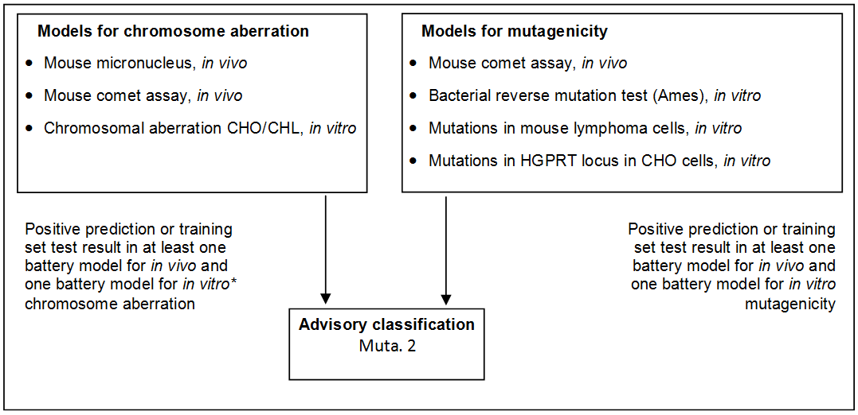
*Training set data was not used for the chromosomal aberrations in CHO cells models as this was proprietary information in the commercial model.

Figure 2: Schematic diagram illustrating the systematic evaluation applied to assign advisory classifications for mutagenicity.

For a substance to be selected as a probable mutagen it was necessary for the following criteria to be fulfilled: Positive prediction or training set test result in at least one battery model for in vivo and one battery model for in vitro, following either a chromosome aberration track or a mutagenicity track.

7,323of the substances investigated in the current project met the criteria in the systematic evaluation and were assigned advisory classifications Muta. 2.

Carcinogenicity
The criteria for classification for carcinogenicity are divided into 3 different categories:

Classification as carcinogen in category 1A (Carc1A; May cause cancer) is based on a strong causal relationship in humans.

Classification as carcinogen in category 1B (Carc1B; H350: May cause cancer) is based on conclusive animal data from 2 species or 1 species with supportive evidence such as genotoxic effects in vitro or in vivo.

Classification as carcinogen in category 2 (Carc2; H351: Suspected of causing cancer) is subdivided into two:

- Well-investigated substances with restricted tumorigenic effects. It is normally based on clear data of tumour formation in one species. Mutagenicity data in vitro and in vivo can be used as supportive evidence.
- Substances that are insufficiently investigated, but raising concern for man.

(Q)SAR based evaluation

Models predicting four carcinogenicity in vivo endpoints and models predicting four genotoxicity in vitro endpoints were applied in the screening.

There were two models for each of the four carcinogenicity endpoints, licensed from MultiCASE and Leadscope respectively.

For the genotoxicity endpoints, the models applied were battery models which integrate predictions from three individual models for the same endpoint and based on the same training set. To achieve a positive battery-prediction in domain, at least two of the three underlying models should be positive in domain.

All the models are documented in the QSAR Model Reporting Format available at the Danish (Q)SAR database /1,2,3/. Brief results from 5 times two-fold cross-validations of the models are given in Table 3.

Endpoint | N (training set) | Software | Cross validation result (%)ª
FDA RCA cancer male rat (in vivo), commercial models | 1,324 | CASE Ultra | Sens=34.2, Spec=95.0, Conc=63.9
FDA RCA cancer male rat (in vivo), commercial models | 1,324 | Leadscope | Sens=62.6, Spec=74.7, Conc=69.2
FDA RCA cancer female rat (in vivo) , commercial models | 1,321 | CASE Ultra | Sens=44.4, Spec=93.3, Conc=71.6
FDA RCA cancer female rat (in vivo) , commercial models | 1,321 | Leadscope | Sens=57.7, Spec=83.6, Conc=72.7
FDA RCA cancer male mouse (in vivo) , commercial models | 1,197 | CASE Ultra | Sens=38.4, Spec=86.1, Conc=66.1
FDA RCA cancer male mouse (in vivo) , commercial models | 1,197 | Leadscope | Sens=58.6, Spec=81.4, Conc=71.9
FDA RCA cancer female mouse (in vivo) , commercial models | 1,208 | CASE Ultra | Sens=41.5, Spec=85.9, Conc=65.6
FDA RCA cancer female mouse (in vivo) , commercial models | 1,208 | Leadscope | Sens=59.2, Spec=80.6, Conc=71.3
Bacterial reverse mutation test (Ames test in S. typhimurium in vitro) | 4,102 | CASE Ultra | Sens=83.9, Spec=89.1, Conc=86.4
 | 4,102 | Leadscope | Sens=84.3, Spec=85.7, Conc=84.9
 | 4,102 | SciQSAR | Sens=79.3, Spec=79.1, Conc=79.2
Chromosome aberrations in CHO cells (in vitro) | 233 | CASE Ultra | Sens=40.4, Spec=94.5, Conc=74.4
Chromosome aberrations in CHO cells (in vitro) | 233 | Leadscope | Sens=54.1, Spec=79.3, Conc=68.8
Chromosome aberrations in CHO cells (in vitro) | 233 | SciQSAR | Sens=50.5, Spec=84.3, Conc=70.3
Chromosome aberrations in CHL cells (in vitro) | 600 | CASE Ultra | Sens=63.3, Spec=86.7, Conc=76.4
Chromosome aberrations in CHL cells (in vitro) | 600 | Leadscope | Sens=74.6, Spec=75.2, Conc=74.9
Chromosome aberrations in CHL cells (in vitro) | 600 | SciQSAR | Sens=73.0, Spec=72.8, Conc=72.9
Mutations in thymidine kinase locus in mouse lymphoma cells  (in vitro) | 555 | CASE Ultra | Sens=76.5, Spec=86.3, Conc=81.2
 | 555 | Leadscope | Sens=85.1, Spec=83.8, Conc=84.4
 | 555 | SciQSAR | Sens=79.1, Spec=80.5, Conc=79.8
Mutations in HGPRT locus in CHO cells  (in vitro) | 239 | CASE Ultra | Sens=75.4, Spec=84.5, Conc=78.9
Mutations in HGPRT locus in CHO cells  (in vitro) | 239 | Leadscope | Sens=81.7, Spec=78.4, Conc=80.5
Mutations in HGPRT locus in CHO cells  (in vitro) | 239 | SciQSAR | Sens=80.0, Spec=73.0, Conc=76.5
* Crossvalidation by 5 times two-fold procedure. Sens: Sensitivity; Spec: Specificity; Conc: Concordance
Table 3: Technical summary for the carcinogenicity models

Identification of carcinogenic substances
For a substance to be selected as a probable carcinogen it was necessary for the following criteria to be fulfilled: Positive prediction for at least two endpoints of the four cancer endpoints (male/female rat/mouse) in either the Leadscope or CASE Ultra system requiring that the other system does not give a negative in-domain prediction.

Identification of genotoxic carcinogens
While there are many non-genotoxic carcinogens acting by a wide variety of often-unknown mechanisms, it was chosen to focus here on substances likely to cause cancer through a genotoxic mechanism. Therefore, a further selection criterion for genotoxicity was set up.

As opposed to the selection criteria for mutagenicity, not all genotoxic carcinogens are necessarily clastogenic (cause loss, addition or rearrangement of parts of chromosomes). To select the genotoxic substances from the substances already predicted positive for in vivo carcinogenicity, which include genotoxic as well as non-genotoxic carcinogens, a battery of models for sensitive in vitro genotoxicity endpoints was used.

The genotoxicity criterion was a positive estimate in one or more of the models for the following in vitro genotoxicity endpoints; Reverse mutation test (Ames), chromosomal aberrations (CHO/CHL), mutations in mouse lymphoma, or Mutations in HGPRT locus in CHO cells.

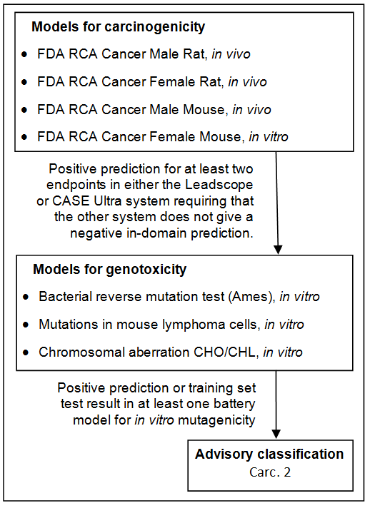

Figure 3: Schematic diagram illustrating the systematic evaluation applied to assign advisory classifications for carcinogenicity.

A schematic diagram of the systematic evaluation is given in Figure 3. According to these criteria, 4,788 of the substances assessed in the current project were identified as genotoxic carcinogens and selected for advisory classification for carcinogenicity. It is not felt that the models employed allow discrimination between classifications in the three categories, so the lower classification Carc. 2 was applied in all cases.

Reproductive toxicity
The criteria for classification for reproductive toxicity are divided into 3 different categories:

Classification as toxic to reproduction in category 1A (Repr1A; H360: May damage fertility or the unborn child) is based on a strong causal relationship in humans.

Classification as toxic to reproduction in category 1B (Repr1B; H360: May damage fertility or the unborn child) is based primarily on animal data, and secondly on “other relevant information”. Data from in vitro studies, or studies on avian eggs, are regarded as “supportive evidence” and would only exceptionally lead to classification in the absence of in vivo data.

Classification as toxic to reproduction in category 2 (Repr2; H361: Suspected of damaging fertility or the unborn child) is based primarily on animal data, and secondly on “other relevant information”. Substances in category 2 are insufficiently investigated, but raising concern for man.

Classification for reproductive toxicity covers a wide range of effects on either fertility or to the developing organism before and after birth (structural or functional damage). The (Q)SAR models applied in the current project only cover certain but far from all types of harm to the unborn child. Hence only certain types of mechanisms causing malformations or foetal mortality are covered. No (Q)SAR models were used for effects concerning other types of developmental toxicity and fertility.

(Q)SAR based evaluation

Two battery models predicting in vivo teratogenicity or fetal lethality related endpoints were applied in the assessment.

QSAR battery models for Teratogenic potential in Humans and for Rodent dominant lethal mutation from the Danish (Q)SAR database

The models from the Danish (Q)SAR database are documented in the QSAR Model Reporting Format available at the Danish (Q)SAR database /1,2,3/. Brief results from 5 times two-fold cross-validations the models are given in Table 4.

Endpoint | N (training set) | Software | Cross validation result, external validation or internal performance (%)*
Teratogenic potential in Humans | 323 | CASE Ultra | Sens=65.0, Spec=85.1, Conc=76.4
Teratogenic potential in Humans | 323 | Leadscope | Sens=72.0, Spec=85.5, Conc=80.1
Teratogenic potential in Humans | 323 | SciQSAR | Sens=64.6, Spec=92.7, Conc=81.4
Dominant lethal mutations in rodents (in vivo) | 191 | CASE Ultra | Sens=42.4, Spec=92.7, Conc=73.7
Dominant lethal mutations in rodents (in vivo) | 191 | Leadscope | Sens=61.5, Spec=80.4, Conc=71.8
Dominant lethal mutations in rodents (in vivo) | 191 | SciQSAR | Sens=57.7, Spec=81.4, Conc=71.7
* Sens: Sensitivity; Spec: Specificity; Conc: Concordance

Table 4: Technical summary for the models for reproductive toxicity.

The dominant lethal test in rodents is initially meant for genotoxicity effects on germ cells, but the resulting effect is early embryonic deaths. Therefore, the endpoint is relevant for reproductive toxicity assessment. In many cases, a toxicological threshold is assumed to exist for reproductive toxicity. With mutagenic substances this may not be the case.

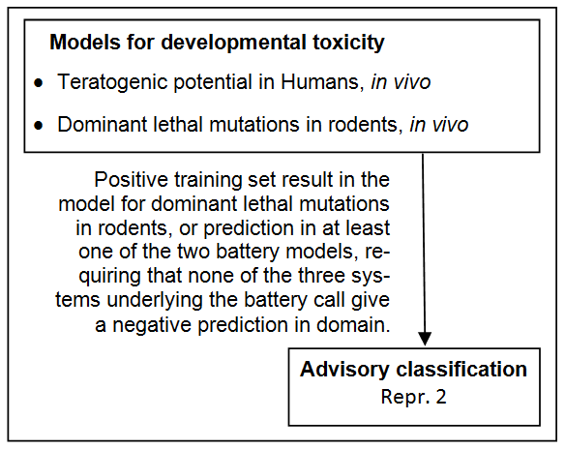
Figure 4: Schematic diagram illustrating the systematic evaluation applied to assign advisory classifications for reproductive toxicity.

For a substance to be selected as probable toxic to reproduction it was necessary for the following criteria to be fulfilled: Positive training set test result in the model for dominant lethal mutations in rodents or positive prediction in at least one of the two battery models, requiring that none of the three systems underlying the battery call give a negative prediction in domain.

The screening resulted in a list of 5,506 positive predictions. The models employed do not allow discrimination between classification in the three classification categories, so the lower classification Repr. 2 was applied in all cases.

Acute oral toxicity
The formalized criteria for classification for acute oral toxicity includes a number of options of tests including fixed-dose procedure and interpretation of the various sources of information about acute oral toxicity, but is often based on acute LD50 tests in the rat for which the following classification criteria are used:

Classification | Classification criteria
AcuteTox1 | ATE ≤ 5 mg/kg body weight
AcuteTox2 | 5 < ATE ≤ 50 mg/kg body weight
AcuteTox3 | 50 < ATE ≤ 300 mg/kg body weight
AcuteTox4 | 300 < ATE ≤ 2000 mg/kg body weight
Table 5: CLP criteria for classification for acute oral toxicity

(Q)SAR based evaluation
If test results measured in the rat by the oral administration route were readily available in RTECS® /4/ these took precedence over any predictions. Moreover, as acute toxicity data from the mouse following a variety of different routes of administration was also available in some cases, this was used to predict rat oral LD50’s using the QAARs (Quantitative activity-activity relationships) preferentially as follows /5,6/:

1. | Log LD₅₀ or., rat = 0.190 + 0.953 * (Log LD₅₀ or., mouse)
 | RTECS data 1989, n=1257, R² = 0.82
2. | Log LD₅₀ or., mouse = 0.682 + 0.373 * (Log LD₅₀ iv., mouse) + 0.518 * (Log LD₅₀ ip., mouse)
 | RTECS data 1994, n = 286, R² = 0.766, Q² = 0.764
3. | Log LD₅₀ or., mouse = 0.731 + 0.841 * (Log LD₅₀ ip., mouse)
 | RTECS data 1994, n=286, R² = 0.724, Q² = 0.724
4. | Log LD₅₀ or., mouse = 0.945 + 0.802 * (Log LD₅₀ iv., mouse)
 | RTECS data 1994, n=286, R² = 0.689, Q² = 0.688
Or.: oral, iv.: intravenous, ip.: intraperitonial

Table 6: QAAR equations for acute oral toxicity correlating mouse and rat data by different routes

Biological data consisting of LD₅₀’s in mice or rats was available a little under 12% of the substances processed.

If no test data were available, rat oral LD₅₀ was estimated according to the ACD/Labs Tox Suites version 2.9.1 acute toxicity LD₅₀ for Rat (oral), which is based on RTECS (Registry of Toxic Effects of Chemical substances) and ESIS (European Survey of Information Society) data for 6,464 substances /1,2,3/.

In the ACD/Labs Tox Suites predictions of LD₅₀ are given together with applicability domain estimates in the form of reliability indexes (RI=Reliability Index), which take into account the similarity of the query compound to the training set, the difference between predicted LD₅₀ and experimental values for similar compounds, and the consistence of experimental values for similar compounds.

The model is documented in the QSAR Model Reporting Format available at the Danish (Q)SAR database /1,2,3/.

Endpoint | N (training set) | Software | External validation results
Acute toxicity LD50 for Rat (in vivo), or. | 6,464 | ACD/Labs Tox Suites v. 2.9.1 | Ext. validation 1: N= 2,167 of which 1,335 (61.6%) had RI >0.5 gave Q²=0.64  Ext. validation 2: N=2,718 of which 1,804 (6.4%) had RI >0.5 gave Q2=0.70

Table 7: Technical summary for the model for acute oral toxicity model

In modern acute oral toxicity tests using small numbers of animals, statistical variation is often within a factor of 2-4, and inter-laboratory variations of up to an order of magnitude is not uncommon /7/.

The accuracy of the ACD/Labs model is considered to be sufficient to differentiate between the three different levels of acute toxicity (“harmful”, “toxic” and “very toxic”).

A schematic diagram of the systematic evaluation is given in figure 5.

This resulted in a total of 23,071 substances with an advisory classification for acute oral toxicity. They were distributed between the categories as follows:

Category | Number with advisory classifications
Acute Tox. 1 | 72
Acute Tox. 2 | 357
Acute Tox. 3 | 2,967
Acute Tox. 4 | 19,675

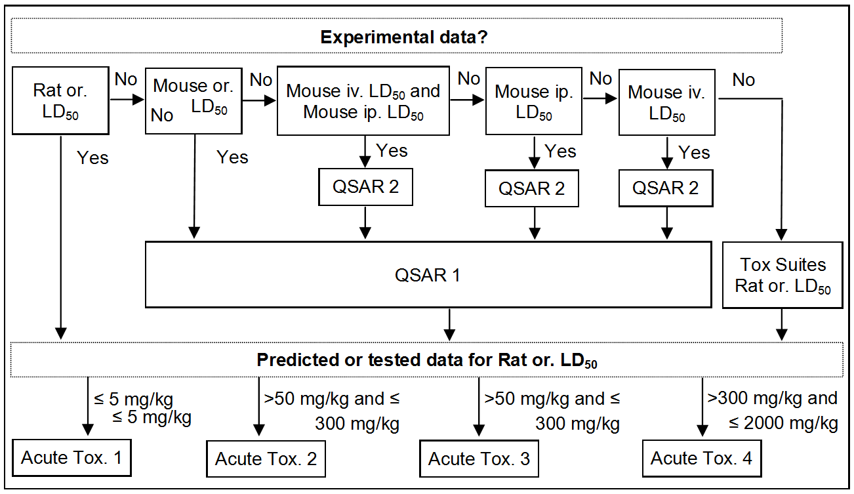

Figure 5: Diagram illustrating the systematic evaluation used to assign advisory classifications for acute oral toxicity

Sensitisation by skin contact
The criteria for classification for sensitisation by skin contact are divided into 3 different categories/sub-categories:

Classification as skin sensitiser in category 1 (Skin Sens.1; May cause an allergic skin reaction). Substances shall be classified as skin sensitisers in category 1 where data are not sufficient for sub-categorisation in accordance with the following criteria:
(a) if there is evidence in humans that the substance can lead to sensitisation by skin contact in a substantial number of persons; or
(b) if there are positive results from an appropriate animal test

Classification as skin sensitiser in sub-category 1A (Skin Sens. 1A; May cause an allergic skin reaction). Substances showing a high frequency of occurrence in humans and/or a high potency in animals can be presumed to have the potential to produce significant sensitisation in humans. Severity of reaction may also be considered.

Classification as skin sensitiser in sub-category 1B (Skin Sens. 1A; May cause an allergic skin reaction). Substances showing a low to moderate frequency of occurrence in humans and/or a low to moderate potency in animals can be presumed to have the potential to produce sensitisation in humans. Severity of reaction may also be considered.

(Q)SAR based evaluation
The models listed in Table 8 for endpoints related to in vivo skin sensitisation were applied in the assessment. The five profilers applied from the OECD QSAR Toolbox were combined with the skin metabolism or autooxidation simulators, and it was required that it was the same transformation product or the parent compound itself which contained at least one alert for protein binding and keratinocyte gene expression.

The models from the Danish (Q)SAR database are documented in the QSAR Model Reporting Format available at the Danish (Q)SAR database /1,2,3/, the VEGA model is documented in the VEGA software /8,9/, and the OECD Toolbox profilers are documented in the Toolbox software /10/. Brief results from 5 times two-fold cross validations or external validation of the models are given in Table 8.

Endpoint / model | N (training set) | Software | Cross validation result or external validation (%)ª
Allergic contact dermatitis in guinea pig and human (commercial model from MultiCASE) | 1,032 | CASE Ultra | Sens=76.7, Spec=93.9, Conc=89.3
 | 1,032 | Leadscope | Sens=75.0, Spec=96.3, Conc=90.8
 | 1,032 | SciQSAR | Sens=61.6, Spec=96.8, Conc=85.8
VEGA Skin Sensitisation (LLNA) Model version 2.1.6 | 167 | VEGA | Ext. validation with 34 positives and 8 negatives gave: Sens= 97, Spec=75, Conc.=93
Protein binding by OASIS 1.4 | N/A (101 alerts) | OECD QSAR Toolbox | N/A
Protein binding by OECD | N/A  (104 alerts) | OECD QSAR Toolbox | N/A
Protein binding potency Cys (DPRA 13%) | 229 (77 alerts) | OECD QSAR Toolbox | N/A
Protein binding potency Lys (DPRA 13%) | 228 (73 alerts) | OECD QSAR Toolbox | N/A
Keratinocyte gene expression | ~300 (21 alerts) | OECD QSAR Toolbox | N/A
* Where not otherwise indicated, the performance was assessed by 5 times two-fold cross validation. The VEGA model was as indicated assessed by external validation. Sens: Sensitivity; Spec: Specificity; Conc: Concordance

Table 8: Technical summary for the models for sensitisation by skin contact

A schematic diagram of the systematic evaluation is given in figure 6.

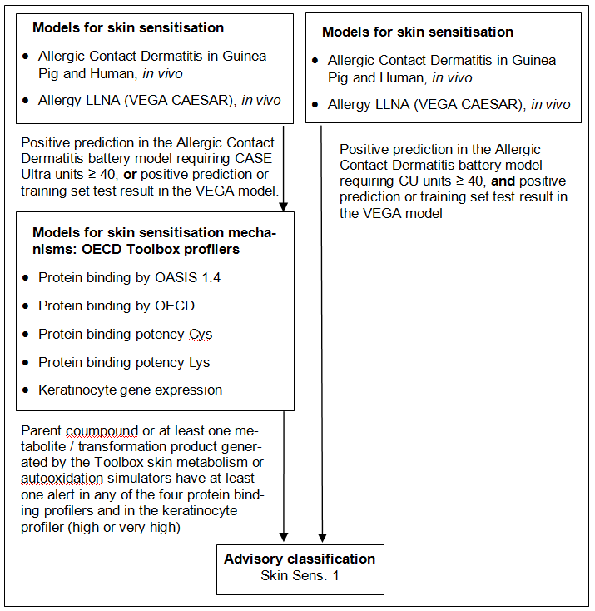

Figure 6: Schematic diagram illustrating the systematic evaluation applied to assign advisory classifications for sensitisation by skin contact

9,325 substances met the above criteria, for which an advisory classification of Skin Sens. 1 was assigned.

Skin irritation
This endpoint can result in a classification for skin irritation category 2
(SkinIrr2; Causes skin irritation).

(Q)SAR based evaluation
If test results measured in the rabbit were readily available (had been used to make the model) these took precedence over any predictions.

If no test data were available, skin irritation was estimated according to the Danish (Q)SAR database battery-model for severe skin irritation vs. mild skin irritation. As the model training set contains both information on skin irritation and corrosion, positive predictions from the model may in reality be due to either of the effects.

The models from the Danish (Q)SAR database are documented in the QSAR Model Reporting Format available at the Danish (Q)SAR database /1,2,3/. Brief results from 5 times two-fold cross validations are given in Table 9.

Endpoint / model | N (training set) | Software | Cross validation result (%)ª
Severe skin irritation in rabbit | 836 | CASE Ultra | Sens=63.4, Spec=86.7, Conc=75.8
Severe skin irritation in rabbit | 836 | Leadscope | Sens=79.5, Spec=81.7, Conc=80.6
Severe skin irritation in rabbit | 836 | SciQSAR | Sens=77.3, Spec=71.3, Conc=74.3

Table 9: Technical summary for the model for skin irritation

The software used in the current project is unable to predict the properties of ionized compounds (salts) and therefore predictions have not been made for ionized compounds, as skin irritation is a local effect, which can be highly sensitive to pH.

A schematic diagram of the systematic evaluation is given in figure 7.

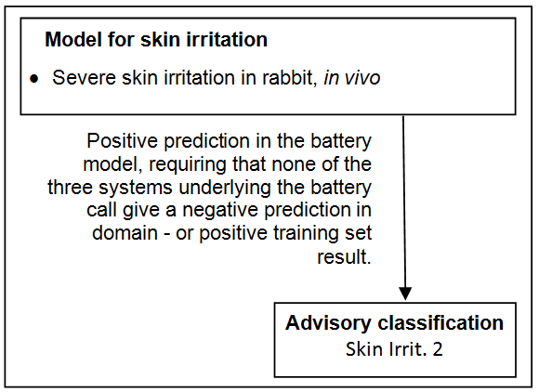

Figure 7: Schematic diagram illustrating the systematic evaluation used to assign advisory classifications for skin irritation

This resulted in 7,670 substances, which were assigned an advisory classification of Skin Irrit. 2. As the model does not discriminate between strong irritants and corrosive substances, the advisory classifications based on the predictions from the model should be considered as “minimum classifications”.

Danger to the aquatic environment
The classification criteria are composed of three main elements: 1) potential for rapid degradation, 2) bioconcentration potential in fish, and 3) short-term toxicity to aquatic organisms (fish, daphnia, and algae). Classifications are assigned according to the following scheme:

Classification | Classification criteria*
Acute1  Very toxic to aquatic life | Acute toxicity ≤ 1.0 mg/L
Chronic1  Very toxic to aquatic life with long lasting effects. | Acute toxicity ≤ 1.0 mg/L  and not readily degradable or  BCF**≥ 500
Chronic2  Toxic to aquatic life with long lasting effects. | Acute toxicity > 1 and ≤ 10 mg/L and not readily degradable or  BCF ≥ 500
Chronic3  Harmful to aquatic life with long lasting effects. | Acute toxicity > 10 and ≤ 100 mg/L and not readily degradable or BCF ≥ 500
Chronic4  May cause long lasting harmful effects to aquatic life | Cases when data do not allow classification under the above criteria but there are nevertheless some grounds for concern
* The lowest effect concentration, LC₅₀ / EC₅₀, for fish, daphnia or algae is used
** BCF: Bioconcentration factor

Table 10: EU criteria for classification for danger to the aquatic environment

(Q)SAR based evaluation
Advisory classifications were assigned on the basis of combinations of estimates for ready biodegradability, bioconcentration and acute toxicity according to the criteria in Table 10, see list of models in Table 11 and Figure 8.

Advisory classification with risk phrase Chronic4 was not done in this exercise, as only the systematic criteria was taken into consideration.

It is noted that compared to the classification criteria according to which abiotic degradation (and assessment of primary degradation products for their environmental hazard classification) can be used, only predictions concerning potential for rapid biodegradation was employed here. Furthermore only predictions for bioconcentration in fish were used even though the classification criteria refers to use of log Kow when reliable measured BCF data in fish are not available.

The models from the Danish (Q)SAR database are documented in the QSAR Model Reporting Format available at the Danish (Q)SAR database /1,2,3/, the EPI Suite v4.11 models are documented in the software /11 /. Brief results from 5 times two-fold cross validations are given in Table 9.

Endpoint / model | N (training set) | Software | Cross validation result (%)ª
Biowin2 (non-linear model) Probability of Rapid Biodegradation | 295 | EPI Suite 4.1  BIOWIN 4.10 | Ext. validation: N=884 MITI substances (385 ready: 499 not-ready) gave Sens=53.3%, Spec=86.0% /12/
BCF | 527 | EPI Suite 4.1, BCFBAF 3.01 | Ext. validation: N=158 gave Q²=0.82, Std.Dev.=0.59, Avg.Dev.=0.46 /11/
BCF Arnot-Gobas (upper trophic) Including Biotransformation | N/A | EPI Suite 4.1,  BCFBAF 3.01 | N/A
Fathead minnow 96h LC50 (mg/L) | 565 | Leadscope | R²=0.75, Q²=0.73
Fathead minnow 96h LC50 (mg/L) | 565 | SciQSAR | R²=0.74, Q²=0.72
Daphnia magna 48h EC50 (mg/L) | 626 | Leadscope | R²=0.67, Q²=0.64
Daphnia magna 48h EC50 (mg/L) | 626 | SciQSAR | R²=0.65, Q²=0.63
Pseudokirchneriella s. 72h EC50 (mg/L) | 531 | Leadscope | R²=0.74, Q²=0.71
Pseudokirchneriella s. 72h EC50 (mg/L) | 531 | SciQSAR | R²=0.64, Q²=0.60
Non-polar narcosis, LC₅₀ (equilibrium) = 8.15 mmol /BCF | N/A | Theoretical equation | N/A
ECOSAR equations for acute toxicity to Fish, Daphnid and Algae using the prediction from the ECOSAR chemical class giving the lowest prediction (mg/L) | Many equations | EPI Suite 4.1  ECOSAR 1.11 | Ext. validation: N=27 gave Q²=0.74 /13/

Table 11: Technical summary for the models used for classification of danger to the aquatic environment.

Acute toxicity
For aquatic toxicity classifications, it is recommended to use L(E)C₅₀-values for fish, daphnia and algae. Aquatic toxicity to fish, daphnia and algae were predicted using models and a theoretical equation. The models were used for substances with Log K_{ow} up to six, and the predictions were combined into a geometric mean. The theoretical equation was used for substances with a Log K_{ow} greater than six.

Based on predictions from models for acute toxicity to Fish, Daphnia and Algae, the geometric mean was calculated based on predictions in AD (where there was no solubility warnings for the individual systems) from Leadscope, SciQSAR and ECOSAR. If one was not in the domain, the two other were used. If two were not in domain the third was simply taken.

For substances with a Log K_{ow} greater than six, all substances were assumed to act by non-polar narcosis (minimum or baseline toxicity), and toxicity at dynamic equilibrium (or steady state) was estimated according to a relation to the predicted bioconcentration factor in small fish:

LC₅₀ (equilibrium) = 6.0 mmol/kg /BCF

The critical body residue (CBR) is the concentration of chemical bio-accumulated in an aquatic organism that corresponds to a defined measure of toxicity, e.g., mortality (Lethal Body Burden, LBB). The CBR has been proposed as a better estimator of dose than the external water concentration. It is assumed to be constant for chemicals with the same mode of action, and it is studied most for the narcotic effect to small fish. LBBs for non-polar narcosis lethal effects to fish are generally assumed to be within the range of about 2–8 mmol/kg /15,16 /. The choice of 6.0 mmol/kg corresponds to the a value slightly higher than the median of the interval of 2-8 mmol/kg, resulting in a screening approach which is probably is more likely to slightly underestimate toxicity.

While simple Log K_{ow} relationships exist for predicting the non-polar narcotic toxicity for fish, daphnia and algae, these do not distinguish specific toxicity’s unique to any of the three taxa, and were not felt to offer any advantage over using the fish models alone, which also adequately predict non-polar narcosis. For all practical purposes, non-polar narcosis induces effects at the same concentration levels in all three taxa for substances with these high Log K_{ow} values.

A schematic diagram of the systematic evaluation is given in figure 8.

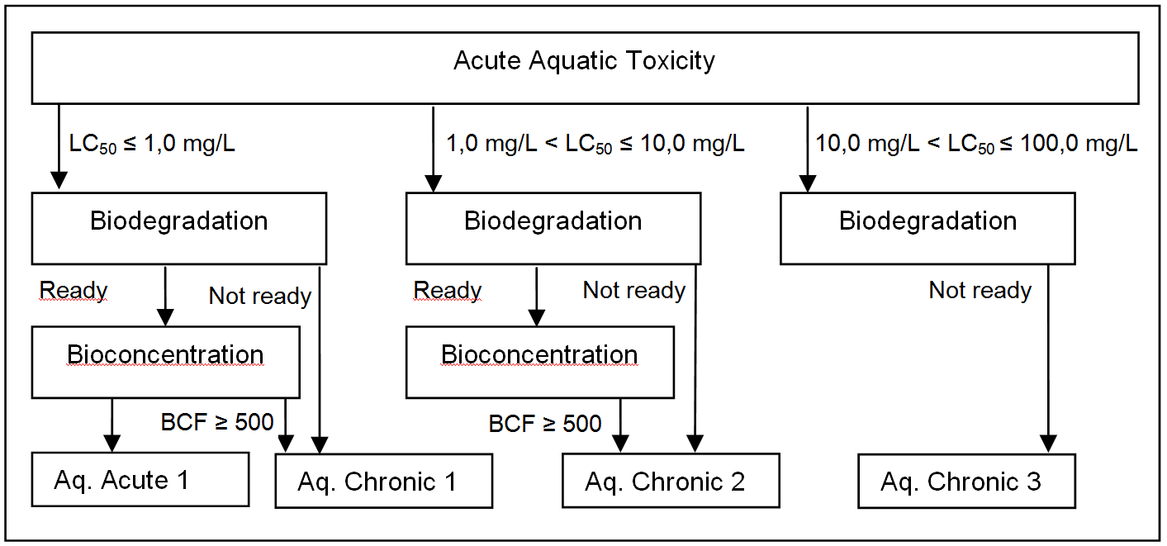

Figure 8: Schematic diagram illustrating the systematic evaluation applied to assign advisory classifications for danger to the aquatic environment.

Advisory classifications

A total of 33,615 of the substances assessed in the current project were selected according to one of the four classification categories based on the combination of model predictions as indicated in the classification criteria and shown in Error: Reference source not found8.

The classifications for danger to the aquatic environment were assigned to the following number of substances:

Category | Number with advisory classifications
Aquatic Acute1 | 19,414
Aquatic Chronic1 | 12,052 (all of these also have Acute 1)
Aquatic Chronic2 | 8,952
Aquatic Chronic3 | 5,309

References
1 | Danish (Q)SAR database, free online system available from November 2015, http://qsar.food.dtu.dk (accessed 18th December 2017).
2 | Danish (Q)SAR database manual accessed at http://qsardb.food.dtu.dk/Danish_QSAR_Database_Draft_User_manual.pdf  (accessed 18th December 2017).
3 | Link to all documentation reports in the QSAR Model Reporting Format (QMRF) contained in the Danish (Q)SAR database, http://qsardb.food.dtu.dk/download/qmrf/QMRF.html (accessed 18th December 2017).
4 | RTECS® (Registry of Toxic Effects of Chemical Substances), version of August 2009 from Symyx Technologies (UK) Limited.
5 | Niemelä, J., “Non-Structural Activity Coefficients for Acute Oral Toxicity in the Mouse and Rat”, Danish EPA, working document, 1992.
6 | Niemelä, J., “Acute Toxicity versus rout of Administration in Mice”, Danish EPA, working document, 1995.
7 | Hunter, W.J., et. al., “Intercomparison Study on the Determination of Single administration Toxicity in Rats,” J. ASSOC. AFF. ANAL. CHEM., Vol. 62, no. 4, 1979.
8 | VEGA QSAR, freely available system for download at https://www.vegahub.eu/portfolio-item/vega-qsar/  (accessed 18th December).
9 | VEGA Guide to Skin Sensitisation Model version 2.1.6.
10 | OECD QSAR Toolbox version 4.1 launched by the OECD on 8 August 2017, free download at http://toolbox.oasis-lmc.org/?section=download (accessed 18th December 2017).
11 | EPI Suite™ - Estimation Program Interface v4.11 can be downloaded from this US EPA site: https://www.epa.gov/tsca-screening-tools/download-epi-suitetm-estimation-program-interface-v411 (accessed 18th December 2017).
12 | Tunkel, J., Howard, P.H., Boethling, R.S., Stiteler, W., Loonen, H. Predicting Ready Biodegradability in the Japanese Ministry of International Trade and Industry Test. Env. Toxicol. Chem. 19(10); 2478-2485, 2000.
13 | Tunkel, J., et al. (2005), "Practical Considerations on the Use of Predictive Models for Regulatory Purposes", Environmental Science and Technology, 39(7): 2188-2199. ECOSAR
14 | ECHA REACH Guidance on Information Requirements and Chemical Safety Assessment Chapter R.11: PBT/vPvB assessment Version 3.0 June 2017, see page 131-133.
15 | ECHA REACH Guidance on Information Requirements and Chemical Safety Assessment Chapter R.11: PBT/vPvB assessment Version 3.0 June 2017, see pages 131-133.
16 | M. G. Barron , M. J. Anderson , J. Lipton & D. G. Dixon (1997) Evaluation of Critical Body Residue QSARS for Predicting Organic Chemical Toxicity to Aquatic Organisms, SAR and QSAR in Environmental Research, 6:1-2, 47-62, DOI: 10.1080/10629369708031724.
17 | ECHA REACH Guidance on information requirements and chemical safety assessment Chapter R.6: (Q)SARs and grouping of chemicals. European Chemicals Agency, 2008.

Annex 1. Short glossary
 | Description
Training set | The collection of experimental data on a range of substances that have been used to develop the (Q)SAR-model.
Sensitivity | The sensitivity is a measure of how well the model ”catches” the substances with positive effect in relation to the endpoint being modelled. A sensitivity of 80% means that 80% of the ”true positives” in the validation set were correctly predicted as positives (the remaining 20% were falsely predicted as negatives (false negatives)). The sensitivity is not dependent on the prevalence of positives in the “chemical universe”.
Specificity | The specificity is a measure of how well the model predicts substances with lack of effects in relation to the endpoint modelled. A specificity of 80% means that 80% of the ”true negatives” in the validation set were correctly predicted as negatives (the remaining 20% of the negatives were falsely predicted as positives (false positives)). The specificity is not dependent on the prevalence of negatives in the “chemical universe”.
Concordance | Also referred to as overall accuracy. The concordance is an overall measure of the correctness of the predictions. A concordance of 80% means that 80% of the substances in the validation set were correctly predicted as positives or negatives (the remaining 20% are the false predictions i.e. false negatives and false positives).
Predictive values | Positive and negative predictive values, PPV and NPV are measures of how well the model positive or negative predictions, respectively, are correct. A PPV of 80% means that 80% of the positive predictions in the validation set were correct (the remaining 20% were false positives). The predictive values are dependent on the split between positives and negatives in the “chemical universe”.
Applicability domain | The Applicability Domain (AD) of a (Q)SAR expresses the limits of the training set of the model for which it can give predictions for new compounds with a reliability as determined in the validation. The limits of the training set are expressed by parameters characterising the physico-chemical, structural or biological space of the model. The development of statistical and mathematical methods for defining applicability domains is an active field of current research /17/.
Validation | Validation is a trial of the model performance for a set of substances independent of the training set, but within the domain of the model. The model predictions for these substances are compared with measured endpoints for the substances in order to establish the sensitivity and specificity and overall accuracy of the model.

